**Database Development and Class Registration**

Jaime Aviles

University of Arizona Global Campus

CST 499

Doctor Amr Elchouemi

1/17/23

**Introduction**

The integration of MySQL and PHP has become a crucial aspect of web development, as it allows for the creation of dynamic and interactive websites. MySQL, being one of the most popular relational database management system, stores and manages data, while PHP, a server-side scripting language, retrieves and displays that data to users. Together, these technologies provide the foundation for building powerful and efficient web applications. Mastering the integration of MySQL and PHP is essential for creating dynamic and interactive websites that can easily manage and display data.

**Create Your Tables Within the MySQL Database Related to Rest of Your Design.**

This is the code for setting up the semesters, courses, and student enrollment tables that will be used to register courses as well as delete them:

-- Create table for Semesters

**CREATE** **TABLE** tblsemesters **(**

id INT **NOT** **NULL** AUTO_INCREMENT **PRIMARY** **KEY,**

semester VARCHAR**(**255**)** **NOT** **NULL**

**);**

-- Create table for Courses

**CREATE** **TABLE** tblcourses **(**

id INT **NOT** **NULL** AUTO_INCREMENT **PRIMARY** **KEY,**

availability INT **NOT** **NULL,**

course VARCHAR**(**255**)** **NOT** **NULL,**

semester_id INT **NOT** **NULL,**

**FOREIGN** **KEY** **(**semester_id**)** **REFERENCES** tblsemesters**(**id**)**

**);**

-- Create table for enrolling for courses

**CREATE** **TABLE** tblenrollment **(**

**record** INT **NOT** **NULL** AUTO_INCREMENT **PRIMARY** **KEY,**

course VARCHAR**(**255**)** **NOT** **NULL,**

studentID VARCHAR**(**255**)** **NOT** **NULL,**

firstName VARCHAR**(**255**)** **NOT** **NULL,**

lastName VARCHAR**(**255**)** **NOT** **NULL,**

semester VARCHAR**(**255**)** **NOT** **NULL,**

semester_id VARCHAR**(**255**)** **NOT** **NULL**

**);**

-- Create table for the waiting list

**CREATE** **TABLE** tblwaitlist **(**

course VARCHAR**(**255**)** **NOT** **NULL,**

studentID VARCHAR**(**255**)** **NOT** **NULL,**

firstName VARCHAR**(**255**)** **NOT** **NULL,**

lastName VARCHAR**(**255**)** **NOT** **NULL,**

semester VARCHAR**(**255**)** **NOT** **NULL,**

semester_id VARCHAR**(**255**)** **NOT** **NULL,**

email VARCHAR**(**255**)** **NOT** **NULL**

**);**

-- Insert semesters into table

**INSERT** **INTO** tblsemesters **(**semester**)** **VALUES**

**(**'Summer 2023'**),**

**(**'Fall 2023'**),**

**(**'Fall 2023'**),**

**(**'Winter 2023'**);**

-- Insert courses into table

**INSERT** **INTO** tblcourses **(**semester_id**,** course**,** availability**)** **VALUES**

**(**1**,** "ENG101-Essays for College Level"**,** 5**),**

**(**1**,** "SCI101-Science for College Level"**,** 0**),**

**(**1**,** "MAT101-College Level Algebra"**,** 10**),**

**(**1**,** "PSY101-Psychology 1"**,** 9**),**

**(**2**,** "ENG201-Literature 1"**,** 2**),**

**(**2**,** "SCI201-Science 2"**,** 20**),**

**(**2**,** "MAT201-College Level Trigonometry"**,** 11**),**

**(**2**,** "PSY201-Psychology 2"**,** 1**),**

**(**3**,** "ENG301-Literature 2"**,** 30**),**

**(**3**,** "SCI301-Physics 1"**,** 7**),**

**(**3**,** "MAT301-Calculus 1"**,** 0**),**

**(**3**,** "GEN301-College Level GenEd"**,** 15**),**

**(**4**,** "ENG328-Technical Documentation"**,** 4**),**

**(**4**,** "SCI399-Physics 2"**,** 22**),**

**(**4**,** "MAT399-Calculus 2"**,** 10**),**

**(**4**,** "GEN499-Capstones to General Education"**,** 3**)**

**;**

MySQL With Project Database Before Additional Adding Tables.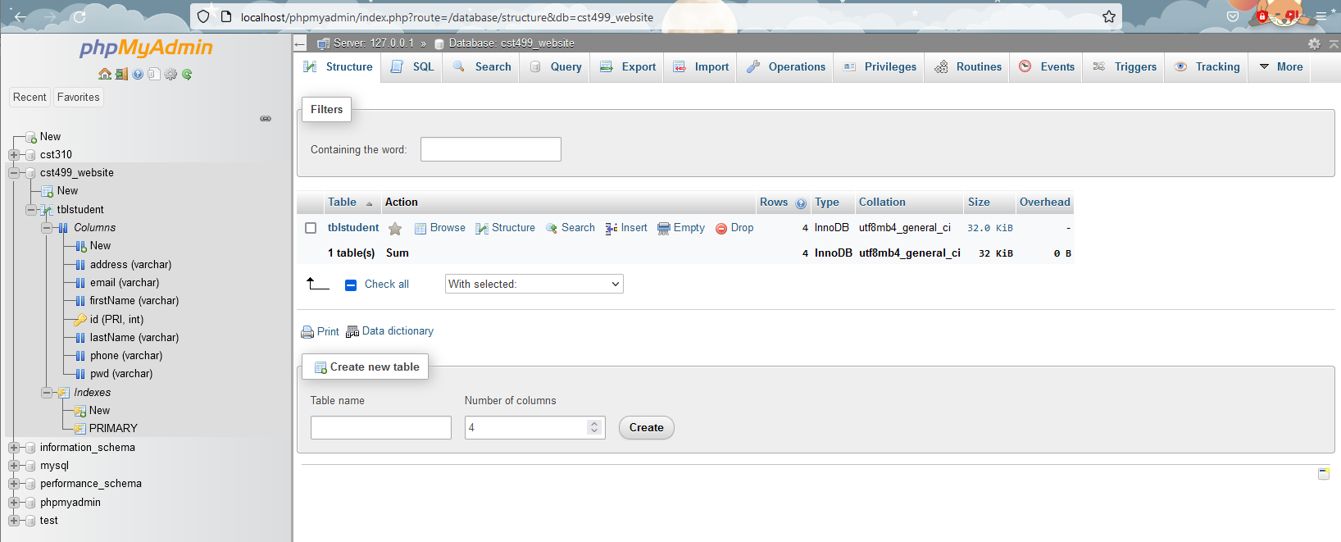

MySQL With Project Database After Adding Tables and Data.

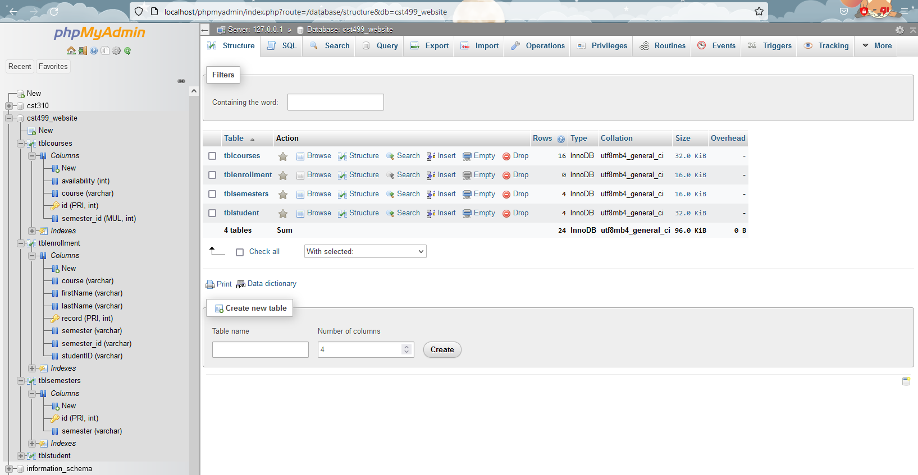

Course Table with Data Fields.

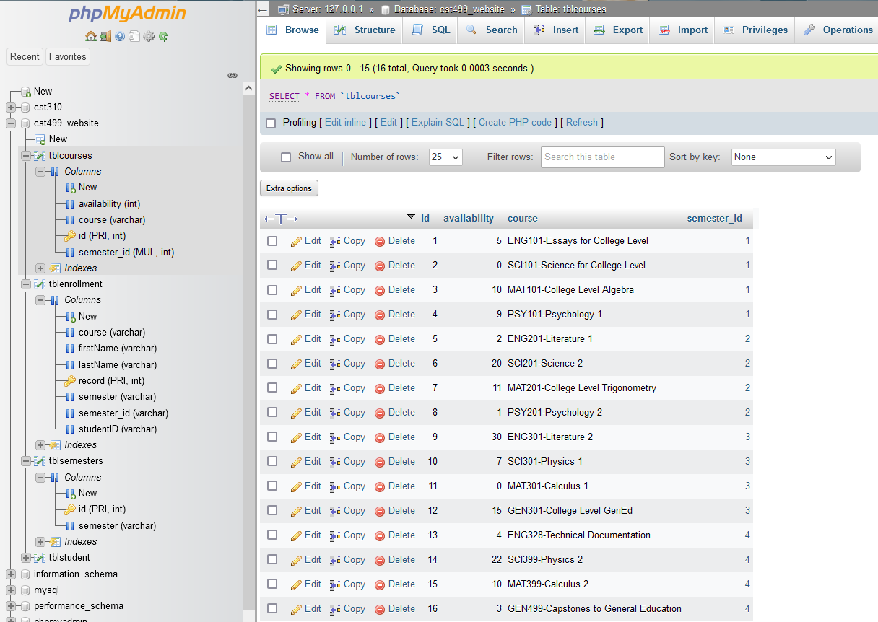

Semesters Table with Data Fields.

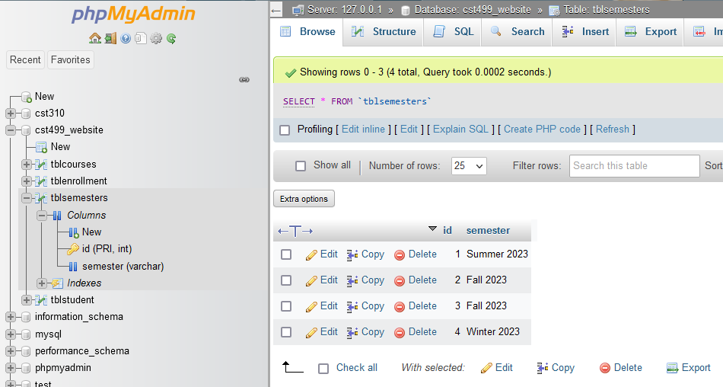

**Create the Different Pages Related to the Rest of the Requirements and Generate Screenshots of the Different Pages.**



Adding a Course.



My Courses Page-Empty.



My Courses Page with Courses Added.

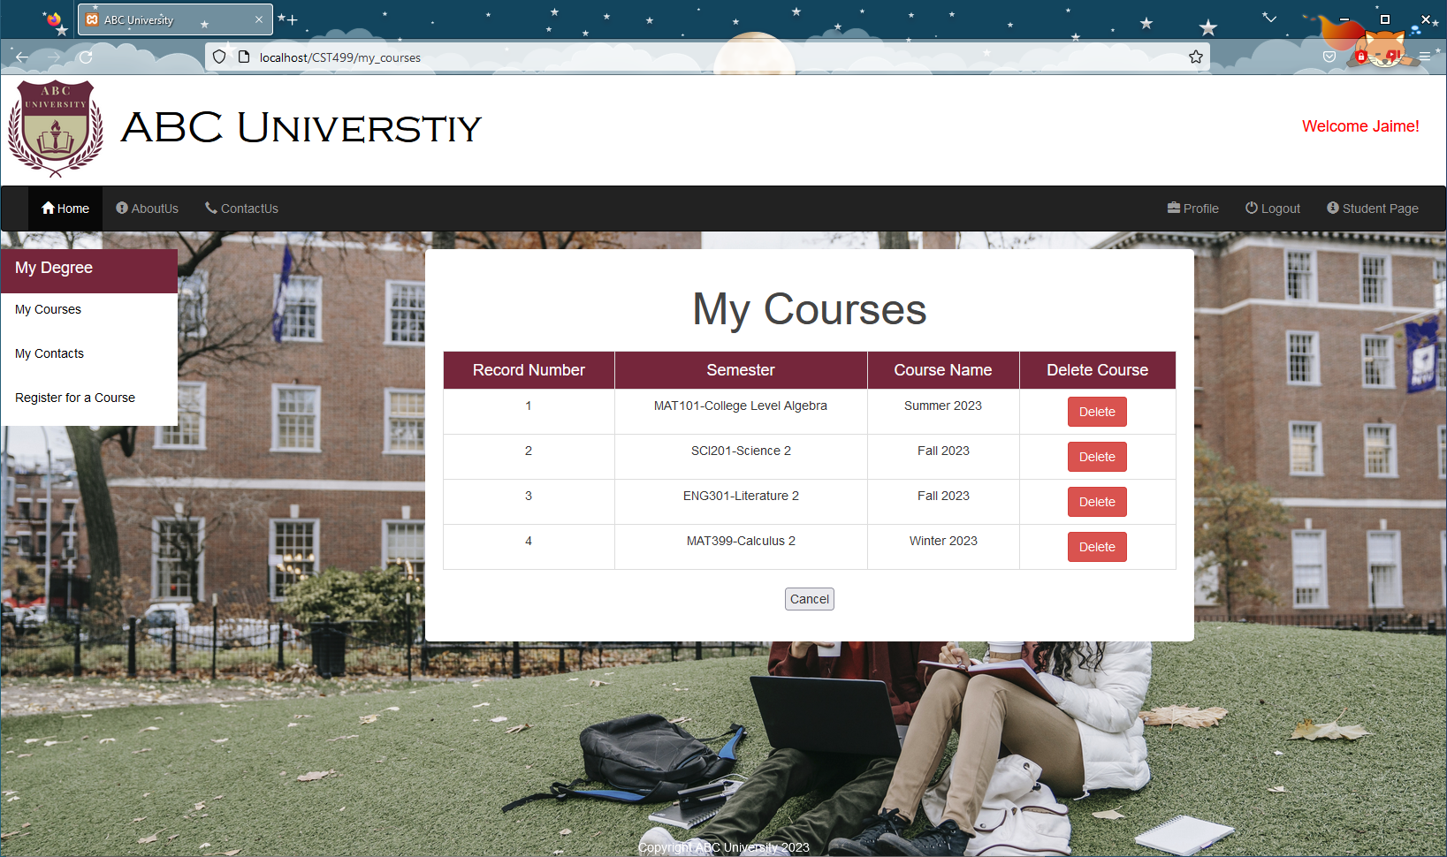

Deleting a Course.



**Generate Screenshots of the PHP Code to Implement Your Logic.**

PHP Code for the Course and Semester Data Gathering.

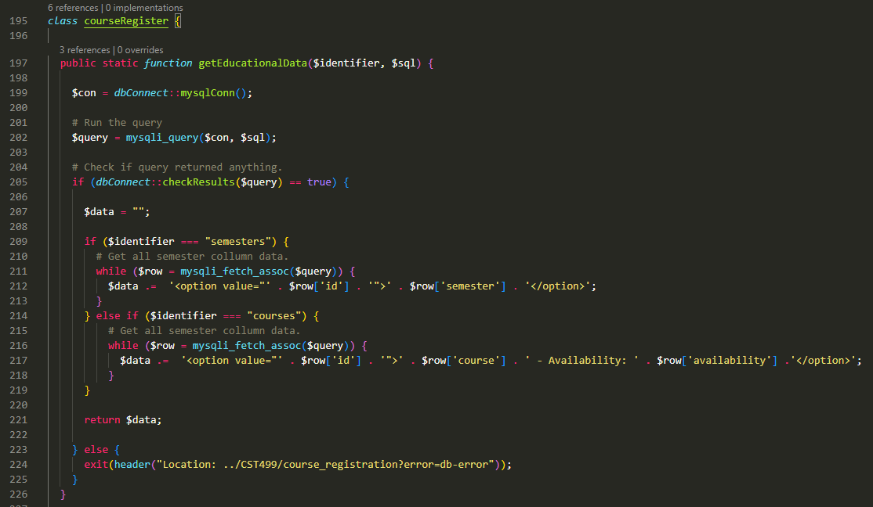

PHP Code for Getting the Student Course Data to Display in the ‘My Courses’ Page.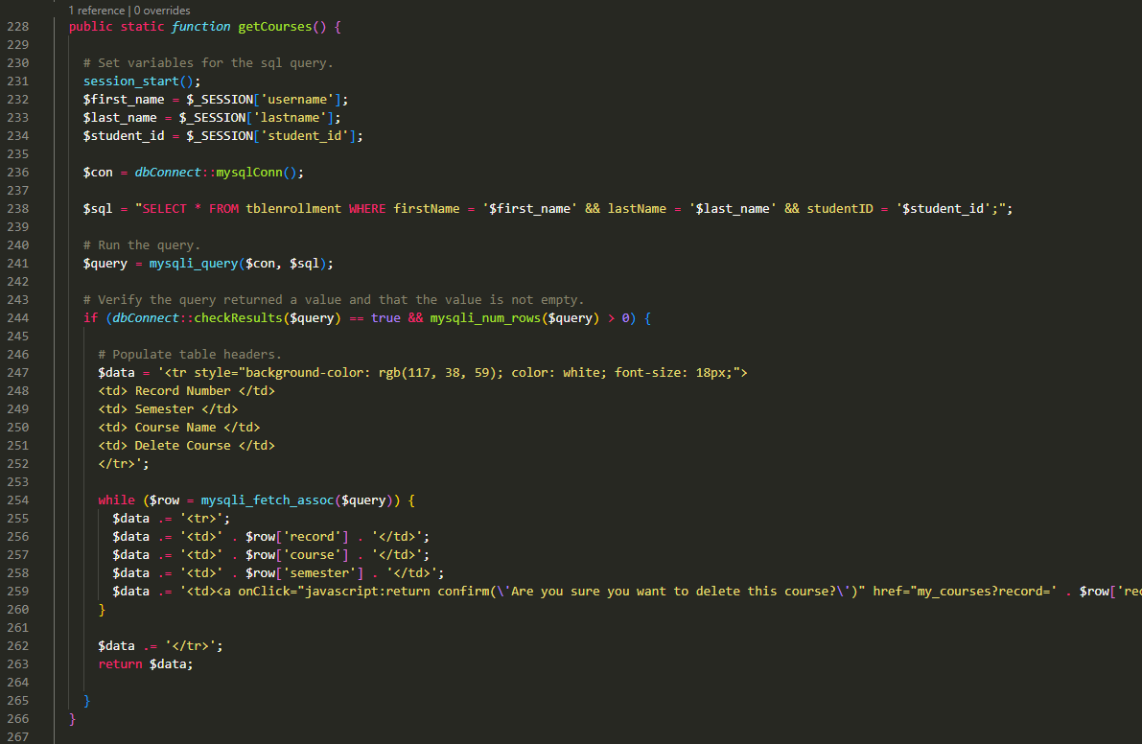

PHP code for registering a course to the student, verifying the student is not already registered to a selected class, and decrementing the availability. *Please note, this PHP code is 93 lines and only a portion is displayed here*

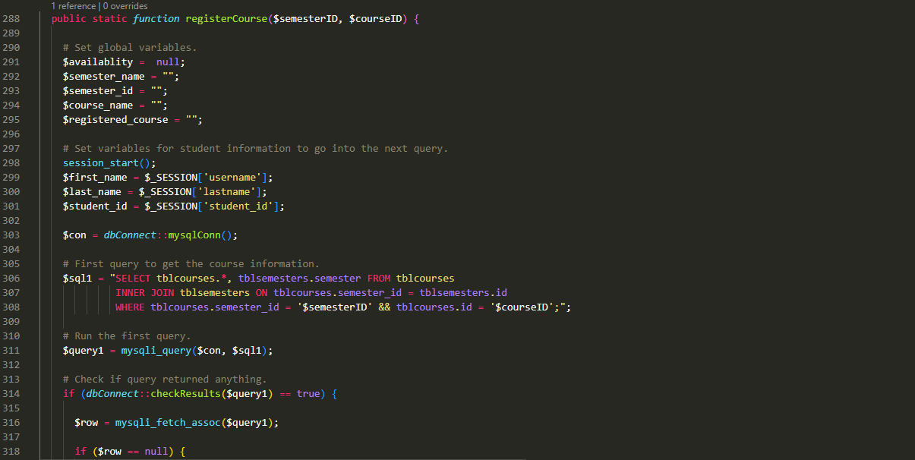

All of the above PHP code is handled by a separate PHP file called ‘course_handling.php.’

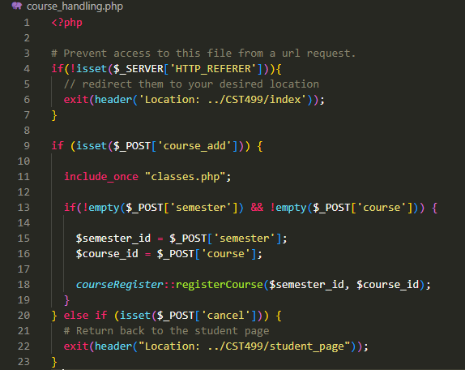

**Summarize Your Experience Going Through the Implementation Phase.**

The experiences going through the implementation phase was unique because features in JavaScript, MySQL and PHP that were previously unknown needed to be discovered. To properly register a student to a course and set that information to the enrollment table, information about referencing tables by specific column named needed to be learned. It was discovered that foreign keys and key constraints, which allows users to cross-reference data that is related across tables to keep the data consistent, was the feature in MySQL that would achieve this goal (*MySQL :: MySQL 5.6 Reference Manual :: 13.1.17.5 FOREIGN KEY Constraints*, n.d.).

Next came the method to more than a single query to the MySQL database through PHP. It was found that the PHP built in function `mysqli_multi_query()`, which allows to execute multiple queries asynchronously before returning control back to the PHP process, will handle this task as needed (*PHP: Mysqli::Multi_Query - Manual*, n.d.).

Lastly, to get the course information based on the semester chosen by the student required JavaScript. This method requires both the ajax functionality and a jQuery library to implement. Once the jQuery source reference was added, the JavaScript code will be triggered by the PHP ‘onchange’ method that points to the JavaScript function. In the JavaScript code, an ajax request (`$.ajax()`) will fetch the dependent data from the database without the need of a page refresh. The ajax properties ‘url,’ ‘data,’ and ‘type’ were used to get the required data value, the PHP method (POST or GET), and the PHP code that will execute the database query process (JS Foundation - js.foundation, n.d.).

Lastly, organizing the student course information required learning about developing tables. On clicking the ‘My Courses’ link, all student courses will be displayed in a table that is

generated by PHP code. The table is created using HTML `<table>` tags with its associated `<tr>` (table row) and `<td>` (table data) tags (*HTML Table Basics - Learn Web Development | MDN*, 2023). An additional button is added at the end of each course row that will allow users to delete the course. The button will place variable values in the HTML reference and triggered by the PHP GET method. If all values are set properly, the ‘course_handling.php’ file will execute the query to remove the course from the enrollment table and increment the course availability in the course table.

Throughout the development of the code and webpages required many instances of refactoring, improving the code base without changing its behavior, and testing, the process of fixing bugs found in the code (Tsui, Karam, Bernal, 2018). There were many instance where the queries would not generate the necessary results and hours of troubleshooting was needed to discover what was causing these issues. Overall, the process of learning all new methods lead to a better website design that was once difficult to image being possible.

**Conclusion**

Understanding the basics of connecting to a database, executing queries, and displaying results using PHP and MySQL allows developers to build powerful and efficient web applications. The integration of MySQL and PHP provides the foundation for managing and displaying data on a website, making it a crucial skill for any web developer to master. As the demand for data management and display on web applications continues to grow, the expertise of integrating MySQL and PHP will become an increasingly valuable skill for web developers

**References:**

*HTML table basics - Learn web development | MDN*. (2023, January 5). https://developer.mozilla.org/en-US/docs/Learn/HTML/Tables/Basics

JS Foundation - js.foundation. (n.d.). *jQuery.ajax() | jQuery API Documentation*. https://api.jquery.com/jquery.ajax/

*MySQL :: MySQL 5.6 Reference Manual :: 13.1.17.5 FOREIGN KEY Constraints*. (n.d.). https://dev.mysql.com/doc/refman/5.6/en/create-table-foreign-keys.html

*PHP: mysqli::multi_query - Manual*. (n.d.). https://www.php.net/manual/en/mysqli.multi-query.php

Tsui, F., Karam, O., & Bernal, B. (2018). *Essentials of software engineering* (4th ed.). Jones & Bartlett Learning.